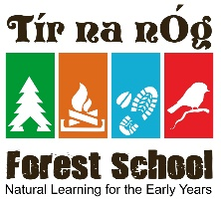
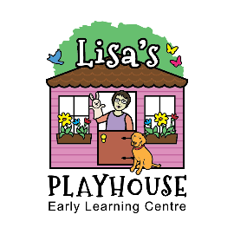
PARENT REFERRAL
REWARDS PROGRAM
RECEIVE A DISCOUNT ON TUITION

Current Parents - Take advantage of our referral reward program by recommending a friend, co-worker or another family member to Lisa’s Playhouse or Tír na nÓg Forest School - Sussex. There are no limits on referrals!
This is how it works...what ever the new family signs up for per week you get the equivalent week free. It has no monetary value. The credit will be issued to your oldest child. The referral credit will be issued after the referred child has completed 30 days of childcare. You will receive a Reward Referral card with your name on it and the new family brings it in when they register.
Alumni Families – The rewards do not stop even after a family has graduated out of our program! If a new family is referred to us by one of our alumni families, the alumni family will receive a $10 gift card from Taste and See & Stable Grounds Café.
Give the below sheet to a friend today!

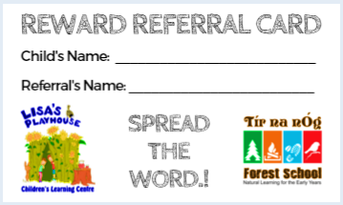

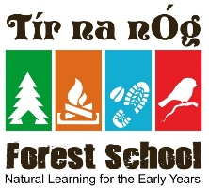
PARENT REFERRAL
REWARDS PROGRAM
RECEIVE A DISCOUNT ON TUITION

Current Parents - Take advantage of our referral reward program by recommending a friend, co-worker or another family member to Lisa’s Playhouse or Tír na nÓg Forest School - Sussex. There are no limits on referrals!
This is how it works...what ever the new family signs up for per week you get the equivalent week free. It has no monetary value. The credit will be issued to your oldest child. The referral credit will be issued after the referred child has completed 30 days of childcare. You will receive a Reward Referral card with your name on it and the new family brings it in when they register.
Alumni Families – The rewards do not stop even after a family has graduated out of our program! If a new family is referred to us by one of our alumni families, the alumni family will receive a $10 gift card from Taste and See & Stable Grounds Café.
Give the below sheet to a friend today!
